Subscripts and Pascal’s Triangle

Here is the start of Pascal’s Triangle:

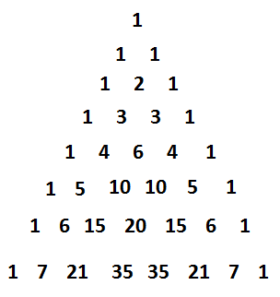

If you have not seen this before, note first that each successive row of the triangle has one additional value. The top row has one value in it. The next row has two values. The following row has three values, and so on. Second, each row starts and ends with the value 1. Third, the rows are symmetric, i.e., the numbers on the left reflect the same values that are on the right.

One can construct the triangle after a start of 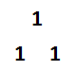 by starting and ending the new row with a “1”, and then making the interior numbers be the sum of the numbers to the left and right above them. Thus, we get 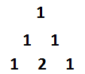 where the 2 comes from 1+1. Reviewing the original triangle we see that the row after the 1 2 1 row follows this same pattern. We can look at this pattern, putting in spaces for the next row and showing the origins of each of the interior numbers as 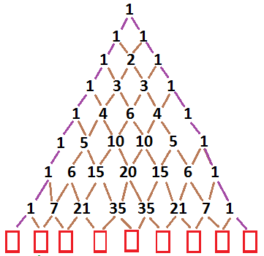. It is easy to apply our rules to fill in the missing values in the new row. We put a 1 at each end. The interior numbers become of the numbers to the left and right above the new space. In that way we get the new row as 1, 8, 28, 56, 70, 56, 28, 8, and 1. This methodology can be used to expand the triangle for as many rows as we want. However, getting the twenty-first row would take a tremendous amount of work if we follow this pattern. We want to examine another approach to Pascal’s Triangle, but to do so we need to agree on some names for things. We will number the rows, but we will start with the top row as row zero. 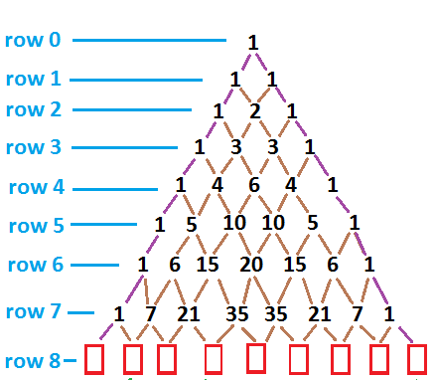 Then we will continue naming the rows. Next we will number the items in our current row, in this case row 8, again starting at 0 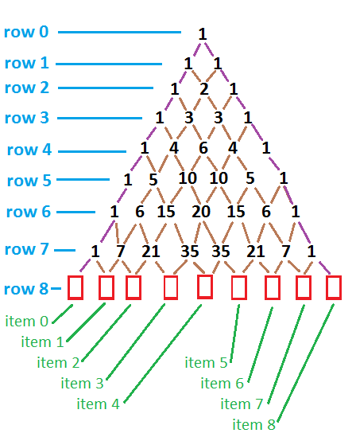 . This gives us a way to talk about particular items. The value in row 8, item 3, will be the sum of 21 and 35. If we use subscripts we can call the value in row 8, item 3 the variable v8,3. Using this subscript naming convention, we get that v6,4 is 15 and v9,6 will be 126. In general, we understand that vr,i is the value in row “r”, item “i”.

There is a nice expression that gives us the value in vr,i and that is

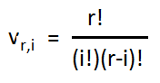

(remember that 6!=6\*5\*4\*3\*2\*1, and that 1!=1, and 0! Is defined to be 1). We can try this out on the row 8, item 6:

v8,6 = 8!/(6!\*(8-6)!)) = 8!/(6!\*2!) = (8\*7)/2 = 28, exactly the value that we had before. By using this formula, we can compute the value in the twenty-first row, item 4 because it will be

v21,4 = 21!/(4!\*(21-4)!) = 21!/(4!\*17!)= 21\*20\*19\*18/(4\*3\*2\*1)=7\*5\*19\*9=5985.

In the same way, in row 35 the sixth item is

V35,6 = 35!/(6!\*(35-6)!) = 35!/(6!\*29!)=35\*34\*33\*32\*31\*30/(6\*5\*4\*3\*2\*1)=7\*17\*11\*8\*31\*5=1,623,160.

In all of this it is essential to remember that we start our rows at row 0 and our items at item 0. Thus, for row 12, item 12 we have v12,12 = 12!/(12!\*(12-12)!)=12!/(12!\*0!)=12!/(12!\*1)=12!/12!=1, but we already knew that would be the answer since v12,12 is the last item in the row and each row ends with a 1.